**Health Tracker**

In this project, you are expected to design and develop a health tracking applicationfor adult men and women Android mobile users by considering object-oriented design and programming paradigm. This application must contain at least three functionalities that are explained below.

1. **Body mass index (BMI)** [1]

Reaching and maintaining a healthy weight is important for overall health and can help you prevent and control many diseases and conditions. If you are overweight or obese, you are at higher risk of developing serious health problems. Body mass index (BMI) is a measure of body fat based on height and weight that applies to adult men and women by using Equation 1. The value obtained from the calculation of BMI is used to categorize whether a person is underweight, normal weight, overweight or obese depending on what range the value falls between as seen in Table 1.

|  |  |
| --- | --- |
| BMI = weight (kg) ÷ height2 (m2) | (1) |

Table 1. Weight categories according to BMI

|  |  |
| --- | --- |
| **Weight categories** | **BMI** |
| Underweight | <18.5 |
| Normal weight | 18.5–24.9 |
| Overweight | 25–29.9 |
| Obesity | 30 or greater |

You are expected to design and develop a form to calculate BMI index by taking necessary information from the user, and then inform the user about his/her weight category.

1. **Estimated Energy Requirement (EER)** [2]

EER is average dietary energy intake that is predicted to maintain energy balance in healthy, normal weight individuals of a defined age, gender, weight, height, and level of physical activity consistent with good health. EER is calculated by using Equation 2. The PA values used in Equation 2 can be obtained from Table 2 thanks to gender and daily physical activity level.

|  |  |
| --- | --- |
|  | (2) |

Table 2. Physical Activity Coefficients (PA values) for use in EER equations 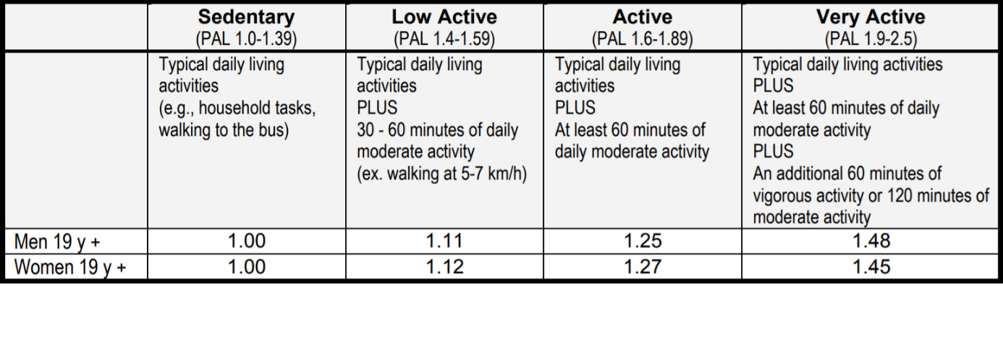

You are expected to design and develop another form to calculate EER by taking necessary information from the user, and then inform the user about his/her daily estimated energy requirement.

1. **Personal Health Tracking**

In this part of the project, you are required to take daily personal blood pressure (tension), blood sugar, heart rate (pulse), weight information from the user. If the entered values are out of the normal ranges, you should inform the user. In addition, you are expected to present weekly or monthly graphics for monitoring changes in these values.

**PROJECT TEAM**

You can form groups up to **3** students and you are required to write your group members to a Google sheet that is editable by students in classroom.

**DUE DATE**

11:59 pm. (23:59), 19th May 2019, Sunday (Late uploads NOT graded)

You are required to upload your Android Studio project to Google Classroom.

**CONTROL**

You are required to present your application on an Android device with your source code. Your project controls will be done between the dates 20th and 28th May 2019.

**References**

[1] <https://www.nhlbi.nih.gov/health/educational/lose_wt/BMI/bmi-m.htm>

[2] <https://www.canada.ca/content/dam/hc-sc/migration/hc-sc/fn-an/alt_formats/hpfb-dgpsa/pdf/nutrition/dri_tables-eng.pdf>